# **19 - PostgreSQL 17 Performance Tuning: GIN (Generalized Inverted Index)**

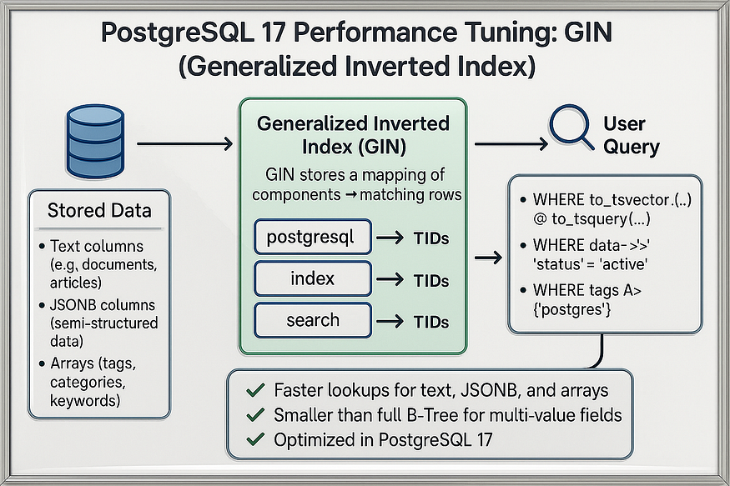

PostgreSQL is famous for its indexing capabilities. Beyond the common ****B-Tree index****, PostgreSQL supports powerful index types for specialized workloads. One of the most important is the ****GIN (Generalized Inverted Index)****.

## **What is GIN in PostgreSQL?**

****GIN (Generalized Inverted Index)**** is a special type of index in PostgreSQL designed to handle complex data types where a single column can contain ****multiple values****. Instead of storing data in a sorted order like a B-Tree, a GIN index works by creating an ****inverted map**** — it records *which rows contain a particular value*.

This makes it ideal for searching inside:

* ****Arrays**** → e.g., find all employees who have 'PostgreSQL' in their skills array.
* ****JSONB documents**** → e.g., find all records where "status": "active".
* ****Full-text search**** → e.g., find all articles containing the word "database".

## **How GIN Works**

Think of a GIN index like the index at the back of a book:

* For each keyword, it lists the pages where that word appears.
* Similarly, for each value in an array, JSONB document, or text field, GIN records the rows where that value exists.
* When you query, PostgreSQL just looks up the map instead of scanning the whole table.

## **Key Features of GIN**

* ****Optimized for containment checks (@>, ?, @@)****  
  Example: skills @> ARRAY['PostgreSQL'] → fast with a GIN index.
* ****Great for multi-valued fields****  
  Handles arrays, JSONB, full-text documents.
* ****Not useful for range queries****  
  Unlike B-Tree, GIN indexes can’t efficiently process <, >, BETWEEN.
* ****Larger and slower to update****  
  GIN indexes take more storage and can be slower on inserts/updates compared to B-Tree. But they give huge speedups for searches.

## **When to Use GIN**

✅ Use when:

* You frequently query inside arrays, JSONB documents, or text fields.
* Your queries use operators like @>, ?, or full-text search.

❌ Avoid when:

* You need range queries (<, >, BETWEEN).
* You need frequent updates on large datasets where index maintenance cost is high.

👉 In short:  
A ****GIN index in PostgreSQL**** is like a lookup map for multi-valued or document-like data. It makes queries on arrays, JSONB, and text fields ****much faster****, turning what would be full table scans into quick index lookups.

## **Step 1: Creating the employees table**

Let’s create a table where each employee has a list of skills. Instead of storing skills as separate rows, we’ll store them in an ****array column****.

CREATE TABLE employees (  
 emp_id BIGINT,  
 emp_name TEXT,  
 skills TEXT[] -- array of skills for each employee  
);

postgres=#  
postgres=# CREATE TABLE employees (  
 emp_id BIGINT,  
 emp_name TEXT,  
 skills TEXT[] -- array of skills for each employee  
);  
CREATE TABLE  
postgres=#

📌 Why arrays?  
Arrays are useful when each entity (like an employee) can have multiple values in a single column (like skills). This design avoids join overhead but requires smart indexing for fast searches.

## **Step 2: Insert 1 million rows with random skills**

We’ll load one million rows where each employee has at least one skill, randomly assigned.

-- Insert 1M rows with random skills  
INSERT INTO employees (emp_name, skills)  
SELECT   
 'Employee_' || g,  
 ARRAY[  
 (ARRAY['SQL','Python','PostgreSQL','Java','C++','Tableau',  
 'AWS','Docker','Kubernetes','PowerBI'])  
 [1 + (random()*9)::int]  
 ]  
FROM generate_series(1, 1000000) g;

postgres=# -- Insert 1M rows with random skills  
INSERT INTO employees (emp_name, skills)  
SELECT  
 'Employee_' || g,  
 ARRAY[  
 (ARRAY['SQL','Python','PostgreSQL','Java','C++','Tableau',  
 'AWS','Docker','Kubernetes','PowerBI'])  
 [1 + (random()*9)::int]  
 ]  
FROM generate_series(1, 1000000) g;  
INSERT 0 1000000  
postgres=#

✅ Now we have:

* 1 million employees
* Each with one randomly assigned skill
* A realistic dataset for testing queries

## **Step 3: Analyze the table**

PostgreSQL relies on statistics to choose query plans. Running ANALYZE ensures the planner has up-to-date information.

ANALYZE employees;

postgres=# ANALYZE employees;  
ANALYZE  
postgres=#

## **Step 4: Query without an index**

Suppose we want to find all employees who know ****PostgreSQL****:

EXPLAIN ANALYZE   
SELECT * FROM employees WHERE skills @> ARRAY['PostgreSQL'];

postgres=# EXPLAIN ANALYZE  
SELECT * FROM employees WHERE skills @> ARRAY['PostgreSQL'];  
 QUERY PLAN  
--------------------------------------------------------------------------------------------------------------------  
 Seq Scan on employees (cost=0.00..22413.00 rows=115367 width=55) (actual time=0.009..247.462 rows=111706 loops=1)  
 Filter: (skills @> '{PostgreSQL}'::text[])  
 Rows Removed by Filter: 888294  
 Planning Time: 0.084 ms  
 Execution Time: 311.761 ms  
(5 rows)  
  
postgres=#

🔎 What happened:

* PostgreSQL did a ****sequential scan****, checking every row.
* Almost ****1 million rows were examined****, with ~99,873 matches.
* Execution took ****~311.761 ms****— too slow for large-scale workloads.

## **Step 5: Create a GIN index**

Now let’s add a GIN index on the skills array column:

CREATE INDEX idx_employees_skills_gin ON employees USING gin (skills);

postgres=# CREATE INDEX idx_employees_skills_gin ON employees USING gin (skills);  
CREATE INDEX  
postgres=#

📌 Why GIN?

* A ****B-Tree index**** is not suitable for array membership checks.
* A ****GIN index**** stores an ****inverted map****: it knows which rows contain each skill.
* This makes queries like skills @> ARRAY['PostgreSQL'] lightning fast.

## **Step 6: Query with the GIN index**

Re-run the same query:

postgres=# EXPLAIN ANALYZE   
SELECT * FROM employees WHERE skills @> ARRAY['PostgreSQL'];

📊 ****Query Plan (with GIN index):****

postgres=# EXPLAIN ANALYZE  
SELECT * FROM employees WHERE skills @> ARRAY['PostgreSQL'];  
 QUERY PLAN  
---------------------------------------------------------------------------------------------------------------------------------------------  
 Bitmap Heap Scan on employees (cost=783.95..12130.70 rows=114700 width=55) (actual time=8.949..101.784 rows=111706 loops=1)  
 Recheck Cond: (skills @> '{PostgreSQL}'::text[])  
 Heap Blocks: exact=9913  
 -> Bitmap Index Scan on idx_employees_skills_gin (cost=0.00..755.27 rows=114700 width=0) (actual time=7.288..7.289 rows=111706 loops=1)  
 Index Cond: (skills @> '{PostgreSQL}'::text[])  
 Planning Time: 0.068 ms  
 Execution Time: 169.715 ms  
(7 rows)  
  
postgres=#

🔥 Performance boost:

* The sequential scan was replaced with a ****Bitmap Index Scan**** using the GIN index.
* Instead of checking every row, PostgreSQL jumped straight to matching rows.
* Execution dropped from ****311.761 ms to ~169.715 ms.****

## **Why GIN Indexes Matter**

* ****Designed for complex data****: GIN indexes make it possible to search ****inside arrays, JSONB documents, and full-text search fields****.
* ****Highly optimized****: Instead of storing full rows, they store a mapping of “value → row IDs.”
* ****Use cases****:
* Arrays: Find employees with a specific skill.
* JSONB: Find documents containing a specific key or value.
* Full-text: Fast search across large text fields.

## **Key Takeaways**

* Without indexes, PostgreSQL falls back to ****sequential scans**** — very expensive on large datasets.
* GIN indexes make ****membership queries**** (@>, ?, @@, etc.) extremely fast.
* In PostgreSQL 17, GIN indexes are fully production-ready and widely used in modern apps handling ****semi-structured data****.

👉 If your application uses ****arrays, JSONB, or full-text search****, GIN indexes are a must-have for performance tuning.